**EX NO:3 WRITING BASIC SQL SELECT STATEMENTS**

## Find the Solution for the following:

**True OR False**

1.The following statement executes successfully.

## Identify the Errors

## SELECT employee_id,last_name,sal*12 ANNUAL SALARY FROM employees;

## False

## The correct statements is SELECT employee_id,last_name,sal*12 FROM employees;

## Queries

2.Show the structure of departments the table. Select all the data from it.

DESC department;

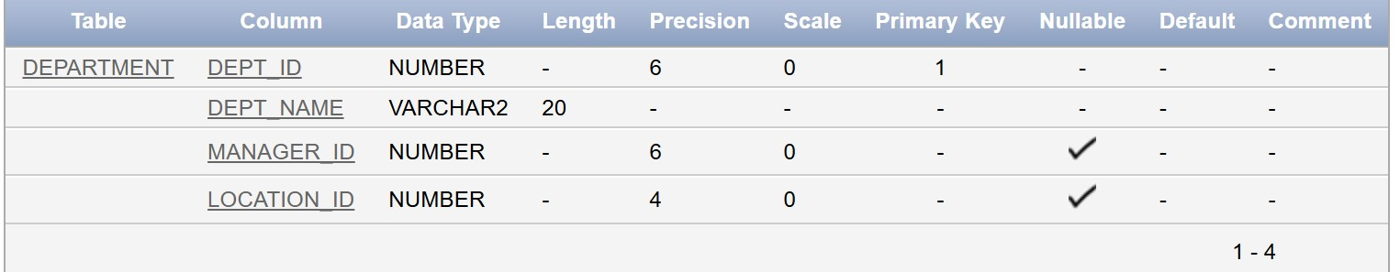

SELECT *FROM department;

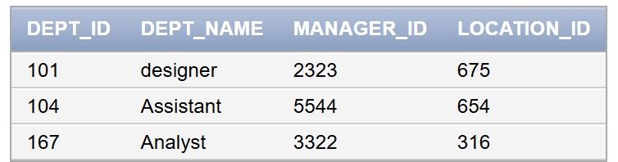

3.Create a query to display the last name, job code, hire date, and employee number for each employee, with employee number appearing first.

SELECT employee_id,last_name,job_code,hire_data FROM employees;

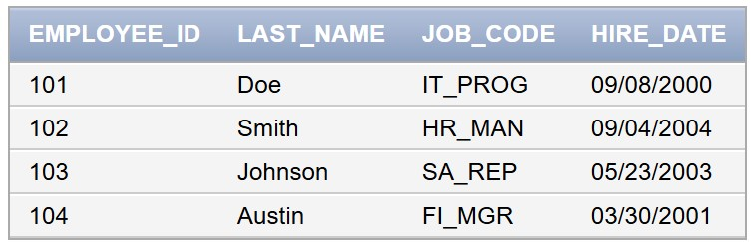

4.Provide an alias STARTDATE for the hire date.

SELECT employee_id,last_name,job_code,hire_date as STARTDATE FROM employees;

5.Create a query to display unique job codes from the employee table.

SELECT DISTINCT job_code FROM employees;

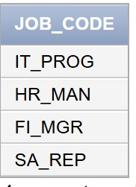

6.Display the last name concatenated with the job ID , separated by a comma and space, and name the column EMPLOYEE and TITLE.

SELECT last_name || ',' || job_code AS EMPLOYEE_AND_TITLE FROM employees;

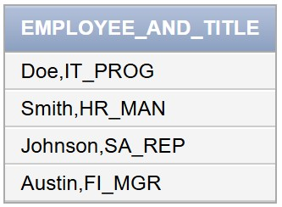

7.Create a query to display all the data from the employees table. Separate each column by a comma. Name the column THE_OUTPUT.

SELECT employee_id || ',' || last_name || ',' || job_code || ','|| hire_date AS THE_OUTPUT FROM employees;

